**Take That 1st Step  
by Richard Woolley**

# Background

Some people sleepwalk through life without truly living. Given some of the best things in life can come free to us, there is an opportunity to create an app that can enlighten people on things they can do to improve their lives. This can include doing acts of kindness, self-reflection and exercise. That, as well as custom goals for each individual, might help people wake up to their lives.

# The System

The system is intended to help people reach their full potentials and live their lives. Therefore, it would produce daily/weekly/monthly goals to get people to do things they might otherwise would not. Given everyone has had their own experiences, the system should allow for users to create their own goals. It will be produced using Unity and C# for Android and IOS. GitHub will be used for version control. These tools and languages have been chosen due to the developer having some experience with using them before. Some competitive apps include:

|  |  |
| --- | --- |
| **App Name & Link** | **Notes** |
| Challenge Of The Day  <https://play.google.com/store/apps/details?id=com.walmin.android.dailychallenge> | * Similar to this system (simple, getting people out of their comfort zone and gives daily goals). * Goals are not always free. * Some goals seem farfetched or ambiguous (skydiving/plan your week). |
| Get out of your comfort zone  <https://play.google.com/store/apps/details?id=io.dkozak.gofycz> | * Unique tasks to be completed every day. * Users considered it unpractical (get on a bus and go anywhere). * Some goals are random. |
| GO DO  <https://play.google.com/store/apps/details?id=com.jcrvlh.godo> | * Different approach, choosing what you want to focus on and then get missions for that. (Nature, WTF, Culture, Food). * Similar to this proposed system but is focused more on doing things with others. * Was very popular but seems to no longer be updated. |
| Iron Will: Quit your addiction  <https://play.google.com/store/apps/details?id=com.emeraldislestudio.fapcounter> | * More emphasis on quitting bad habits. * Great reviews and lots of installs. * Achievements to guide users. * Simplistic design. |
| Challenge Achieved  <https://play.google.com/store/apps/details?id=com.challengeachieved> | * More about creating good habits like exercise or meditation. * Quotes feature. * Some reviews did not like the sharing and feedback section of the app. |

# Users & Use Cases

The user population for the system being created can be defined as:

* Anyone with a smart phone;
* Literate in English;
* Ranging from basic to experience knowledge of using a smart phone;
* Anyone over the age of 13, yet some goals might not be in reach to teenagers.

Some activities a user would want to do with the system include:

* Create their own daily goals. (Exercise, give someone a compliment, confess a regret).
* Identify a habit/activity that can help the user improve their life. This could be building a good, or breaking a bad, habit. (Meditate for 10 minutes for two weeks/write a book about yourself)
* Be inspired to build certain habits or activities. (Mental Health (meditation/living in the present/reflection), Physical Health (Exercise/diet/sleep), Social Health (Calling someone/complementing someone/philanthropy))
* See their progress and feel rewarded from completing goals. Rewards should be better when users complete their own goals. (Positive colours & achievements)

# UI Sketches

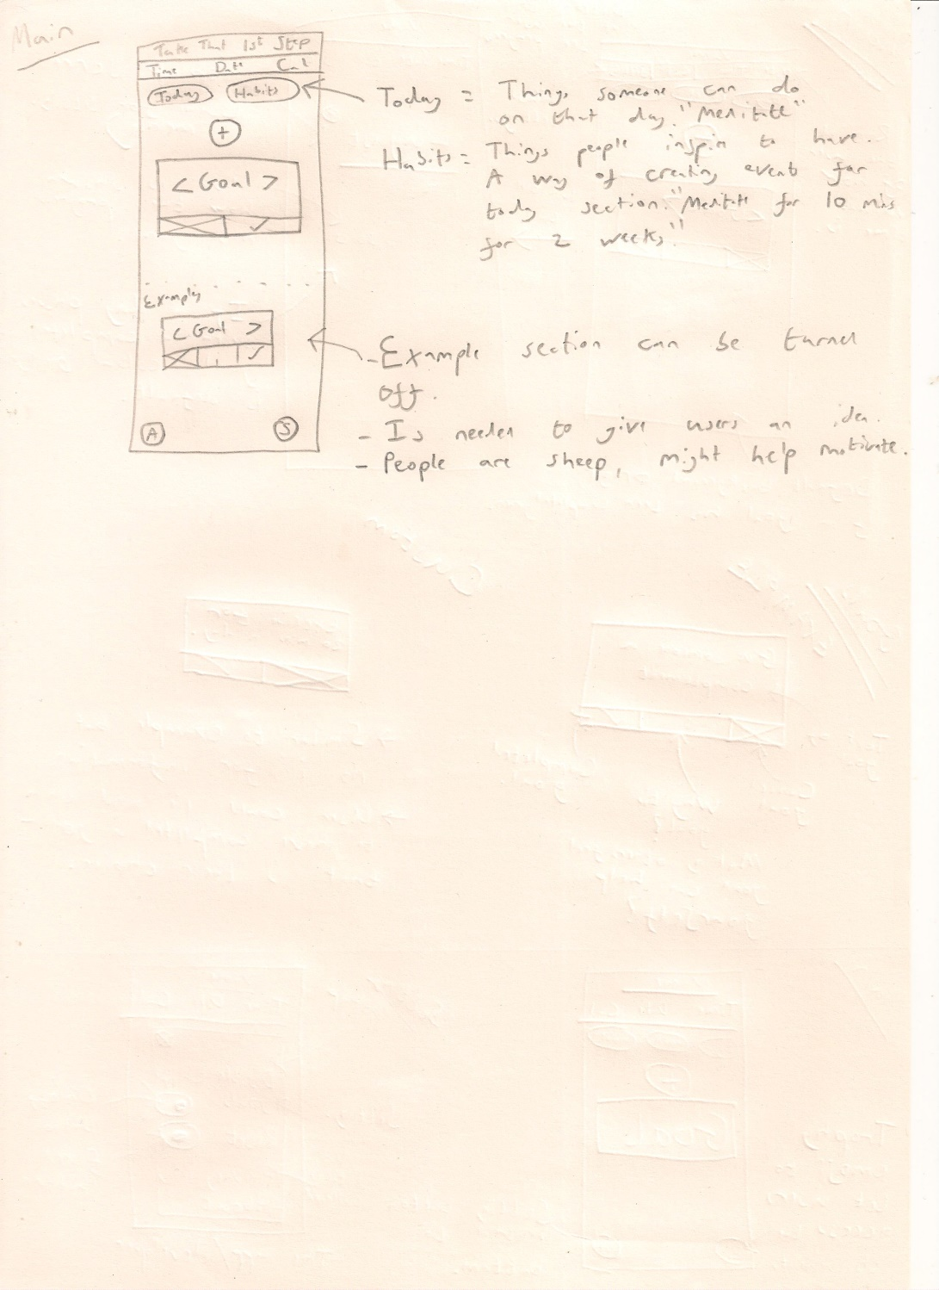

After doing some paper sketches, UI design moved digitally. Please see ‘UI Ideas.pptx’

# UML Class Diagrams

The system is centred on creating goals to be completed every day. A habit is just a goal that someone would like to do every day.

|  |  |  |
| --- | --- | --- |
| **Goal** |  | **Habit** |
| - goal: string  - timeCreated: time | 1 | - habit: string  - daysLeft: int  - dateCreated: date  - timeCreated: time |
| + getGoal(): string  + getTimeCreated(): time | 1 | + getHabit(): string  + getDateCreated(): date  + getTimeCreated(): time  + createGoal(): Goal |